Regulations and Risk Management in the Greek Financial Markets

by

SVETLOZAR T. RACHEV, IRINA N. KHINDANOVA AND BESSY D. ATHANASOPOULOS

University of Karlsruhe, Germany; University of California, Santa Barbara;
and University of Piraeus, Greece.

Regulations and risk management had become vital to the success and survival of the Greek Financial Markets who undergo a rather fast growth recently. In this paper we describe the supervisory authorities and the laws regulating operations of the Greek Financial Markets. The Basle Committee recommendations and the European Commission’s Capital Adequacy Directive are applied to any model developed internally by institutions for statistical measurement of potential market losses. The Value-at-Risk (VaR) models are commonly applied to estimate exposure to market risks. The traditional VaR methodologies - the variance-covariance method, historical simulation, Monte Carlo simulation, and stress-testing - do not provide satisfactory assessment of potential losses. We show superiority of the VaR modeling with stable distributions in evaluation of sensitivity to market risks in Greek financial markets.

Key words and prhases. Greek financial markets, Athens Stock Exchange, Athens Derivatives Exchange, Supervisory authorities, Risk management, Market risks, Capital Adequacy Framework, Value-at-Risk, VaR models, stable distributions.

1. Introduction

Since 1997, the Greek financial markets have experienced significant growth. The convergence of macroeconomic fundamentals to the European average brought down interest rates and enhanced the attractiveness of the Greek capital market. Significant financial institutions have realized that effective, integrated risk management systems are vital to their success and survival. Financial institutions must be able to measure risk and allocate sufficient capital to meet it. The Bank of Greece and the Committee of Capital Market oversee the banking industry and ensure that the Basle Committee’s recommendations and the European Commission’s directives on calculating capital requirements for market risk, are applied to any internal model possible developed for statistical measurement of potential market losses. The Greek banking system is in the process of developing internal models for risk measurement based on the notion of Value at Risk.
The remainder of the paper is organized as follows. Section 2 outlines regulations of Greek financial markets. Section 3 discusses risk management issues such as the capital adequacy framework and Value-at-Risk Models. Our analysis demonstrates that the VaR modeling based on stable distributions outperforms other VaR methodologies in evaluation of sensitivity to market risks for Greek financial markets. Section 4 summarizes conclusions.

2. Regulations of Greek Financial Markets

In this section we describe the supervisory authorities and the laws regulating operations of the Greek financial institutions, including the Athens Stock Exchange, the Athens Derivatives Exchange, and other financial entities.

2.1. Supervisory Authorities

The key players in the regulatory process fall into two categories: supranational regulators and national supervisory authorities. The supranational regulators are the European Commission, which represents the European Union, and the bank for International Settlements (BIS), an offshoot of the group of Thirty (the G30 is a consultative group comprising central banks and the world’s leading private banks). The remit of each body differs considerably. The BIS, via the Basle Committee on Banking Supervision, addresses banks with a substantial volume of international business; it issues recommendations. The European Commission is concerned with financial institutions throughout the European Union, namely banks, stockbrokers and securities houses, regardless of size; it issues directives that are subsequently transposed into legislation in member countries. In Greece, all institutions are subject to European regulations. The second category, national supervisory authorities, oversee the banking industry on behalf of the monetary or governmental authorities of each country. National supervisors are also in charge of inspecting banks that come within the purview of the Basle Committee to ensure that its recommendations are applied. In Greece, the supervisory authorities are the Bank of Greece and the Committee of Capital Market.

2.2. Regulations of the Athens Stock Exchange and Other Financial Institutions

Stock Exchange began to operate unofficially in Greece during the second half of the 19th century. Greek merchants and shipowners were the first brokers to be trading on the unofficial markets of Ermoupolis and Athens both in foreign exchange and securities.

In 1876, the Athens Stock Exchange (ASE) was established , and the first securities to be traded there-in were government bonds and shares of the National Bank of Greece. The first Board of Directors was elected four years later and the Athens Stock Exchange started to operate officially ever since. The Royal Decree of 12/16 June 1909 defined the Exchange, as the sole place of the execution of exchange contracts and transactions on public securities or on securities of recognized Banks and other limited companies.

However, until 1917 there was no supervision of the trading activity and neither the brokers nor the investors were conscious of their duties and responsibilities. In 1918, law 1308 set up Athens Stock Exchange as a public entity. Law 3632/1928 clarified the roles of the trading parties, but only with the enactment of Law 1806/1988, the Athens Stock Exchange was able to progress and to compete with the other European Stock Exchanges.

The principal Laws regulating the operation of the Athens Stock Exchange and other financial institutions are the following:
- 1876 Establishment of the A.S.E. and issue of the first Stock Exchange Law based on the French Commercial Code. Stock Exchange began to operate as a self managed public institution.
- 1928 Law 3632 clarified broker’s and intermediaries` roles and responsibilities.
- 1985 Presidential Decree 350/24.5.1985 set up the basic listing requirements.
- 1988 Law 1806 introduced new concepts in stock exchange function and regulation. It provided the legal framework for the establishment of the Parallel market and the Central Securities Depository. It enlarged Stock Exchange Council and modernized the exchange.
- 1989 Ministerial Decision 6280/B508 defined the legal and financial obligations of Stock Exchange members and Ministerial Decision 6281/B defined the type of information that should appear on the Athens Stock exchange Daily Official List.
- 1990 Law 1892 established the Central Securities Depository (C.S.D.) as a joint stock company.
- 1991 Law 1969 established the Capital Market Committee as a supervisory authority and regulated the operation of Portfolio Investment Companies and of Mutual Funds. Bonds began trading on a net price basis.
- 1992 Presidential Decree 50 specified the type of information that should be included on a company’s prospectus, as well as the procedure that should be followed for its acceptance. It established the mutual recognition of prospectuses, issued and published, in other EC member states. The subject was complemented by Presidential Decree 52, which defined the way prospectuses should be published.
- 1992 Presidential Decree 51 stipulated the information that should be published in large holdings acquisitions.
- 1992 Presidential Decree 53 established the legal framework for the dissemination of confidential and/or inside information.
- 1993 Law 2166 reinforced the role of the Capital Market Commission.
- 1994 Law 2198 introduced the dematerialization of Treasury fixed income securities.
- 1995 Law 2324 transformed the A.S.E. into a joint stock company, supplemented the listing regulations, allowed over the counter (OTC) transactions and short selling (under specific circumstances), defined the conditions for the disposal of shares through private placement, broadened the scope of activities of brokerage companies, allowed remote broking, deregulated commissions and introduced amendements to the Capital Markets Commission regulations.
- 1995 Law 2328 (Article 15) obliged all Greek joint stock companies engaged in public sector projects- including the provision of services- of value greater than one billion GRD to convert their shares into registered up to the individual shareholder. Joint stock companies holding shares in such companies also fall under the obligation to convert their shares into registered.
- 1996 Law 2396 implemented the EU Directives on the Provision of Investment Services and on the Capital Adequacy of Companies Providing Investment Services, legalized the introduction of Greek Certificates into the Greek Capital Markets and enacted the conditions for the share’s dematerialization.
- 1996 Law 2414 introduced an exception to Article 15 of Law 2328/95; shares owned by UCITS, portfolio investment companies of Law 1969/91, banks, insurance companies, brokerage companies and venture capital companies may be exempted from the obligation to convert their shares into registered up to the individual shareholder, provided that their participation into the share capital does not exceed 5%. Banks can hold more than 5% of a company’s non-registered shares, if these shares were acquired either due to underwriting or due to forced sale operations.
- 1996 Law 2372 regulated issues regarding the noncompliance of the companies with the conversion of their shares into registered up to the individual shareholder upon the specified deadline. The repercussions vary according to the days of delay.
- 1997 Law 2533 provided the legal framework for the privatization of the Athens Stock Exchange and created three new markets, the derivatives market, the parallel market for emerging markets and the market for fixed income securities. The composition of the Members` Guarantee Fund was restructured and provisions for short selling and securities lending were introduced.

- Investors’ Protection is ensured by the daily surveillance of transactions by the Ministry of National Economy. A.S.E. member firms are not allowed to trade without the consent of their customers. By decision of the C.M.C., the value all daily trades conducted by the members of the A.S.E., which exceeds the value of their net equity, must be covered by bank guarantees, additional capital or the shares themselves that were traded. When the value of the daily trades exceeds by two times the net equity of the member firm, and no additional guarantees have been provided, access to the electronic trading system is refused to that member firm.

- Market Transparency is enhanced by the following provisions:
- Immediate disclosure by the listed companies of all price sensitive information related to their shares (Presidential Decree 350/85).
- Disclosure within 5 days by the investors of any changes in their participation in a listed company which result in the crossing of the threshhold of 10%, 20%, 1/3, 50%, or 2/3 of the total voting rights in this company. Exemption is provided when the change is attributed to professional action and it results to a change of up to 20% in the total voting rights (Presidential Decree 51/92).
- Disclosure of changes in voting rights by all shareholders holding more than 10% of the total voting rights in a company (Presidential Decree 51/92).
- Disclosure of changes in voting rights equal to or greater than 1.5% of the voting rights in a newly listed company during its first year of listing by all shareholders holding more than 10% of the total voting rights in this company (Law 2533/97).

- Market manipulation: Sanctions against the A.S.E members who use illegal and/or misleading means in order to influence stock prices as well as to those who disseminate misleading information (Law 3632/1928). Prohibition of natural persons to participate both to the Board of Directors of a listed company and to the Board of a member firm (Law 2533/1997).

- Insider trading is prohibited, unless it is conducted by an authorized public organization or a similar institution, for the purpose of exercising monetary and foreign exchange policy or managing public debt (Presidential Decree 53/92).

- Buybacks: Listed companies are allowed to buy back up to 10% of their outstanding shares in order to support their price. The procedure must be disclosed to the public at least 10 days in advance and has to be decided by the General Assembly of the Shareholders of the respective company. Shares acquired through the buyback procedure must be sold back to the market or be distributed to the existing shareholders within three years from their purchase date or else are cancelled.

- Internal audit of A.S.E. members: All A.S.E. members are obliged to be audited by certified auditors.

- Insurance of A.S.E. MEMBERS: The majority of A.S.E. members has insured its obligations to international insurance organizations.
- Trading halts are imposed on stocks, when their price fluctuation on a particular day crosses the limit of 8%, in either direction. Price limits do not apply in the first three days of a company’s listing. This limit will soon be 10%, in either direction.

2.3. Regulations of the Athens Derivatives Exchange

The derivatives market was established in Greece by Law 2533/1997 and started operating on August 27, 1999. It is operated by the Athens Derivatives Exchange (ADEX), which was established in the beginning of 1998 as a subsidiary of the A.S.E.. Clearing in the derivatives market is effected by the Clearing House which was also established in the beginning of 1998. The first steps of the institutional investors in this new market have been of a rather exploratory and gradual nature.
The mechanisms, required for the smooth functioning of the market, seem appropriately designed and up to standard, but this now remains to be seen in practice. Most questions regarding ADEX`s launching are related to the level of liquidity and demand, the identity of the participants, the spread between buying and selling, and how market makers will respond to their role. On the whole, it seems reasonable to expect that ADEX will grow with small but sure steps and the volume of transactions in a new market to be initially limited. Investment companies are expressing the view that ADEX will contribute to market efficiency in both bull and bear spells. Derivatives widen the investors` options in hedging and portfolio management. Hedging aims to cover or reduce risk through the correspondence of derivatives with assets. In portfolio management, they can be used for diversifying assets or improving overall performance. The Capital Market Commission recently set the percentage rates` limit, up to which institutional investors are permitted to invest in derivatives for hedging and portfolio management purposes. Mutual fund company officials are describing the arrangements as satisfactory, although these rule out the setting up of funds exclusively based on derivatives.

3. Risk Management in Greek Financial Markets

The regulatory authorities have endeavored to ensure that banks respect certain standards for controlling risks. Today’s standards are chiefly aimed at protecting bank’s depositors and shareholders, thereby underwriting the credibility of the international banking system. They boil down to a requirement that banks hold a minimum amount of capital against their market exposures.

The 1988 agreement on capital standards was the first step towards a more structured approach to managing risks. The text of the accord, which set a mandatory minimum level of capital to meet credit risk (known as the Cooke ratio), served as a basis for constructing the regulatory framework for market risk-based capital requirements.

Since that time, two texts -an amendment to the Basle agreement specifying the method for calculating capital requirements for market risk and the European Commission’s Capital Adequacy Directive (CAD) - have established the framework within which banks can develop their own models for controlling market risk. The Bank of Greece and the Committee of Capital Market oversee the banking industry and ensure that Basle Committee’s recommendations and European Commission’s directives are applied to any internal model developed for statistical measurement of potential market losses. A commonly used methodology for evaluation of market risks is the Value-at-Risk (VaR). The Greek banking system has not yet applied VaR to estimate possible market losses but it is in the process of doing so.

In the following sections we discuss the Capital Adequacy Framework, describe the VaR methodology, and apply the VaR models for evaluation of exposure to market risks in the Greek financial markets. Our studies show that the “stable” VaR modeling outperforms the traditional “normal” VaR approach.

3.1. Capital Adequacy Framework

The methodological aspects currently used to measure market risk and calculate capital requirements to meet market risks are those specified by the Basle agreement and the European Commission’s Capital Adequacy Directive (CAD). The standard charge method for calculating capital requirements to meet market risks follows:

A. Position Risk

The position risk on a traded debt instrument or equity (or debt or equity derivative) is divided into two components in order to calculate the capital required against it. The first is its specific risk component and the second is its general risk component.

Specific risk is the risk of a price change in the instrument concerned due to factors related to its issuer or, in the case of a derivative, the issuer of the underlying instrument. General risk is the risk of a price change in the instrument due (in the case of a traded debt instrument or debt derivative) to a change in the level of interest rates or (in the case of an equity or equity derivative) to a broad equity-market movement unrelated to any specific attributes of individual securities.

Traded debt instruments

The institution classifies its net positions according to the currency in which they are denominated and calculate the capital requirement for general and specific risks in each individual currency separately.

Specific risk

The excess of an institution’s long (short) positions over its short (long) positions in the same equity, debt and convertible issues and identical futures, options, warrants and covered warrants is its net positions in each of those different instruments. The institution assigns its net positions to the appropriate categories in Table 1 on the basis of their residual maturities and then multiplies them by the weightings shown. Then, it sums its weighted positions (regardless of whether they are long or short) in order to calculate its capital requirement against specific risk.

Table 1

Central government items | Qualifying items |  |  | Other items
 | residual life ≤ 6 months | 6 months < residual life ≤ 2 years | residual life > 2 years
0.00% | 0.25% | 1.00% | 1.60% |  | 8.00%

General risk

In calculating the capital requirement to meet market risk, the institutions are allowed to always use only one of the following methods:

a) Maturity-based method

The procedure for calculating capital requirements against general risk involves two basic steps. First, all positions are weighted according to maturity, in order to compute the amount of capital required against them. In particular, the institution assigns its net positions to the appropriate maturity bands in column 2 and 3 in Table 2 on the basis of residual maturity in the case of fixed-rate instruments and on the basis of the period until the interest rate is next set in the case of instruments on which the interest rate is variable before final maturity. The institution also distinguishes between debt instruments with a coupon of 3% or more and those with a coupon less than 3% and, thus allocates them to column 2 or column 3 in Table 2. Then, it multiplies each of them by the weighing for the maturity band in question in column 4 in Table 2. Consequently, it works out the sum of the weighted long positions and the sum of the weighted short positions in each maturity band. The amount of the former which are matched by the latter in a given maturity band is the matched weighted position in that band, while the residual long or short position is the unmatched weighted position for the same band. The total of the matched weighted positions in all bands then is calculated. The institution computes the totals of the unmatched weighted long positions for the bands included in each of the zones in Table 2 in order to derive the unmatched weighted long position for each zone. Similarly, the sum of the unmatched weighted short positions for each band in a particular zone is summed to compute the unmatched short position for that zone. That part of the unmatched weighted long position for a given zone that is matched with the unmatched weighted short position for the same zone is the matched weighted position for that zone (offset). Therefore, that part of the unmatched weighted long position for a zone that cannot be matched is the unmatched weighted position for that zone (residual). This calculation is made for each zone separately.
Continuing, the amount of the unmatched weighted long (short) position in zone one which is matched by the unmatched weighted short (long) position in zone two is computed. This is further referred to as the matched weighted position between zones one and two. The same calculation is undertaken with regard to that part of the unmatched weighted position in zone two which is left over and the unmatched weighted position in zone three in order to calculate the matched weighted position between zones two and three. The institution may, if it wishes, reverse the above order, i.e. it may calculate the matched weighted position between zones two and three before working out that between zones one and two. The remainder of the unmatched weighted position in zone one is, then, matched with what remains of that for zone three after the latter’s matching with zone two in order to derive the matched weighted position between zones one and three. Residual positions, following the matching calculations mentioned, are summed.

Table 2

Zone | Maturity band t  Coupon > = 3% | Coupon < 3% |  | Weighting  (in %) | Assumed interest rate change (in %)
1 | t ≥ 1 mth  1 < t ≤ 3 mths  3 < t ≤ 6 mths  6 < t ≤ 12 mths | t ≥ 1 mth  1 < t ≤ 3 mths  3 < t ≤ 6 mths  6 < t ≤ 12 mths | 0.00  0.20  0.40  0.70 | 1.00  1.00  1.00
2 | 1 < t ≤ 2 yrs  2 < t ≤ 3 yrs  3 < t ≤ 4 yrs | 1 < t ≤ 1.9 yrs  1.9 < t ≤ 2.8 yrs  2.8 < t ≤ 3.6 yrs | 1.25  1.75  2.25 | 0.90  0.80  0.75
3 | 4 < t ≤ 5 yrs  5 < t ≤ 7 yrs  7 < t ≤ 10 yrs  10 < t ≤ 15 yrs  15 < t ≤ 20 yrs  t > 20 yrs | 3.6 < t ≤ 4.3 yrs  4.3 < t ≤ 5.7 yrs  5.7 < t ≤ 7.3 yrs  7.3 < t ≤ 9.3 yrs  9.3 < t ≤ 10.6 yrs  10.6 < t ≤ 12 yrs  12 < t ≤ 20 yrs  t > 20 yrs | 2.75  3.25  3.75  4.50  5.25  6.00  8.00  12.50 | 0.75  0.70  0.65  0.60  0.60  0.60  0.60  0.60  0.60

The institution’s capital requirement is calculated as the sum of :
- 10% of the sum of the matched weighted positions in all maturity bands;
- 40% of the matched weighted position in zone one;
- 30% of the matched weighted position in zone two;
- 30% of the matched weighted position in zone three;
- 40% of the matched weighted position between zones one and two and between zones two and three;
- 150% of the matched weighted position between zone one and three;
- 100% of the residual matched weighted positions;

Second, allowance is made for the calculated capital requirement to be reduced when a weighted position is held alongside an opposite weighted position within the same maturity band. A reduction in the requirement is also allowed when the opposite weighted positions fall into different maturity bands, with the size of this reduction depending both on whether the two positions fall into the same zone, or not, and on the particular zones they fall into. There are three zones (groups of maturity bands) altogether.

b) Duration-based method

The institution takes the market value of each fixed-rate debt instrument and calculates its yield to maturity, which constitutes the discount rate for that instrument. In the case of floating-rate instruments, the institution takes the market value of each instrument and calculates its yield on the assumption that the principal is due when the interest rate can next be changed. Consequently, the institution calculates the modified duration of each debt instrument on the basis of the following formula:

duration (D)
modified duration = , where:
(1+r)
m t C_{t}
Σ
t=1 (1+r)^{t}
D = , where:
m C_{t}
Σ
t=1 (1+r)^{t}

r = yield to maturity, C_{t} = cash payment in time t and m = total maturity.
The institution then allocates each debt instrument to the appropriate zone in Table 3. It does so on the basis of the modified duration of each instrument.

Table 3

Zone | Modified duration t  (in years) | Assumed interest  (change in %)
One | 0 < t ≤1 | 1.0
Two | 1 <t ≤ 3.6 | 0.85
Three | t > 3.6 | 0.7

The institution calculates the duration-weighted position for each instrument by multiplying its market price by its modified duration and by the assumed-interest rate change for an instrument with that particular modified duration (third column of table 3). The institution works out its duration-weighted long and its duration-weighted short positions within each zone. The amount of the former, which is matched by the latter within each zone, is the matched duration-weighted position for that zone. The institution calculates the unmatched duration-weighted position for each zone. It then follows the procedures laid down for unmatched weighted positions in the maturity-based method.

The institution’s capital requirement is calculated as the sum of:
- 2% of the matched duration-weighted positions for each zone;
- 40% of the matched duration-weighted positions between zones one and two and between zones two and three;
- 150% of the matched duration-weighted position between zones one and three;
- 100% of the residual unmatched duration-weighted positions.

Equities
The institution sums all its net long positions and all its net short positions as mentioned in the case of Traded Debt Instruments. The sum of the two figures is its overall gross position. The difference between them is its overall net position.

Specific risk

In order to calculate its capital requirement against specific risk, the institution multiplies its overall gross position by 4%.

Notwithstanding the latter, the competent authorities may allow the capital requirement against specific risk to be 2% rather than 4% for those portofolios of equities that an institution holds which meet the following conditions:
- the equities are not those of issuers which have issued traded debt instruments that currently attract an 8% requirement in Table 1
- the equities must be adjudged highly liquid by the competent authorities according to objective criteria
- no individual position comprises more than 5% of the value of the institution’s whole equity portofolio. However, the competent authorities may authorize individual positions of up to 10% provided that the total of such positions does not exceed 50% of the portofolio.

General risk

The capital requirement against general risk is the institution’s overall net position multiplied by 8%.

Stock-index futures

Stock-index futures, the delta-weighted equivalents of options in stock-index futures and stock indices collectively referred to hereafter as “stock-index futures”, may be broken down into positions in each of their constituent equities. These positions may be treated as underlying positions in the equities in question; therefore, subject to the approval of the competent authorities, they may be netted against opposite positions in the underlying equities themselves.
The competent authorities ensures that any institution which has netted off its positions in one or more of the equities constituting a stock-index future against one or more positions in the stock-index future itself has adequate capital to cover the risk of loss caused by the future’s values not moving fully in line with that of its constituent equities. They also do this when an institution holds opposite positions in stock-index futures, which are not identical in respect of either their maturity or their composition or both.
Notwithstanding the above two paragraphs, stock-index futures, which are exchange traded and -in the opinion of the competent authorities- represent broadly diversified indices, shall attract a capital requirement against general risk of 8%, but no capital requirement against specific risk. Such stock-index futures are included in the calculation of the overall net position (i.e. in the calculation of the difference between the institution’s net long positions and its net short positions) but disregarded in the calculation of the overall gross position (i.e. in the calculation of the sum of the institution’s net long positions and its net short positions).
If a stock-index future is not broken down into its underlying positions, it is treated as if it were an individual equity. However, the specific risk on this individual equity can be ignored if the stock-index future in question is exchange traded and -in the opinion of the competent authorities- represents broadly diversified index.

Underwriting

In the case of the underwriting of debt and equity instruments, the competent authorities may allow an institution to use the following procedure in calculating its capital requirements. Firstly, it calculates the net positions by deducting the underwriting positions, which are subscribed or sub-underwritten by third parties on the basis of formal agreements. Secondly, it shall reduce the net positions by the following reduction factors:
- working day 0: 100%
- working day 1: 90%
- working day 2 to 3: 75%
- working day 4: 50%
- working day 5: 25%
- after working day 5: 0%
Working day 0 is the working day on which the institution becomes unconditionally committed to accepting a known quantity of securities at an agreed price. Thirdly, the institution calculates its capital requirements using the reduced underwriting positions. The competent authorities ensure that the institution holds sufficient capital against the risk of loss, which exists between the time of the initial commitment and working day 1.

B. Foreign exchange risk

If an institution’s overall net foreign–exchange position, calculated in accordance with the procedure following below, exceeds 2% of its total own funds, it multiplies the excess by 8% in order to calculate its own-funds requirement against foreign-exchange risk. A two-stage calculation is used:
Firstly, the institution’s net open position in each currency (including the reporting currency) shall be calculated. This position consists of the sum of the following elements (positive or negative):
- the net spot position (i.e. all asset items less all liability items, including accrued interest, in the currency in question),
- the net forward position (i.e. all amounts to be received less all amounts to be paid under forward exchange transactions, including currency futures and the principal on currency swaps not included in the spot position),
- irrevocable guarantees (and similar instruments) that are certain to be called,
- net future income/expenses not yet accrued but already fully hedged (at the discretion of the reporting institution and with the prior consent of the competent authorities, not future income/expenses not yet entered in accounting records but already fully hedged by forward foreign-exchange transactions may be included here). Such discretion must be exercised on a consistent basis,
- the net delta (or delta-based) equivalent of the total book of foreign-currency options,
- the market value of other (i.e.. non-foreign-currency) options,
- any positions which an institution has deliberately taken in order to hedge against the adverse effect of the exchange rate on its capital ratio may be excluded from the calculation of net open currency positions. Such positions should be of a non-trading or structural nature and their exclusion, and any variation of the terms of their exclusion shall require the consent of the competent authorities. The same treatment subject to the same conditions as above may be applied to positions which an institution has which relate to items that already deducted in the calculation of own funds
The competent authorities shall have the discretion to allow institutions to use the net present value when calculating the net open position in each currency.

Secondly, net short and long positions in each currency other than reporting currency is converted at spot rates into the reporting currency. Consequently, they are summed separately to form the total of the net short positions and the total of the net long positions respectively. The higher of these two totals is the institution’s overall net foreign-exchange position.

Notwithstanding the above and pending further coordination, the competent authorities may prescribe or allow institutions to use alternative procedures for the purposes of calculating their funds requirement against foreign-exchange risk. In particular:
Firstly, the competent authorities may allow institutions to provide lower capital requirements against positions in closely correlated currencies than those which would result from applying the above procedure to them. The competent authorities may deem a pair of currencies to be closely correlated only if the likelihood of a loss -calculated on the basis of daily exchange-rate data for the preceding three or five years- occuring on equal and opposite positions in such currencies over the following 10 working days, which is 4% or less of the value of the matched position in question (valued in terms of the reporting currency) has a probability of at least 99%, when an observation period of three years is used, or 95%, when an observation period of five years is used. The own-funds requirement on the matched position in two closely correlated currencies is 4% multiplied by the value of the matched position. The capital requirement on unmatched positions in closely correlated currencies, and all positions in other currencies, is 8% multiplied by the higher of the sum of the net short or net long positions in those currencies after the removal of matched positions in closely correlated currencies.
Secondly, the competent authorities may allow institutions to apply an alternative method to those outlined already for the purpose of calculating their capital requirement. The capital requirement produced by this method must be sufficient:
- to exceed the losses, if any, that would have occured in at least 95% of the rolling 10-working-day periods over the preceding five years, or, alternatively, in at least 99% of the rolling 10-working-day periods of the preceding three years, had the institution begun each such period with its current positions;
- on the basis of an analysis of exchange-rate movements during all the rolling 10-working-day periods over the preceding five years, to exceed the likely loss over the following 10-working-day holding period 95% or more of the time or, alternatively, to exceed the 99% or more of the time where the analysis of exchange-rate movements covers only the preceding three years.
Thirdly, the competent authorities may allow institutions to remove positions in any currency which is subject to a legally binding intergovernmental agreement to limit its variation relative to other currencies covered by the same agreement from whichever of the methods described previously that they apply. Institutions calculate their matched positions in such currencies and subject them to a capital requirement no lower than half of the maximum permissible variation laid down in the intergovernmental agreement. Unmatched positions in those currencies are treated in the same way as other currencies.
If an institution’s overall net foreign–exchange position, calculated in accordance with the procedure mentioned earlier, does not exceed 2% of its total own funds, the competent authorities may allow the capital requirement on the matched positions in currencies of the Member States to be 1.6%, multiplied by the value of such matched positions.
The competent authorities notify the Council of the European Union and the European Commission of the methods, if any, that they are prescribing or allowing in respect of the previous paragraphs. The Commission reports to the Council on these methods and, where necessary and with due regard to international developments, proposes a more harmonized treatment of foreign-exchange risk.

3.2. Value-at-Risk Models

A commonly used methodology for estimation of market risks is the Value at Risk (VAR). A VAR measure is the highest possible loss over a certain period of time at a given confidence level. Example: The daily VAR for a given portfolio of assets is reported to be $2 million at the 95 percent confidence level. This value of VAR means that, without abrupt changes in the market conditions, one-day losses will exceed $2 million 5 percent of the time.
Formally, a$\text{VAR}={\text{VAR}}_{t,τ}$ is defined as the upper bound of the one-sided confidence interval:

Pr[ΔP(τ) < -VAR] = 1- c, (1)

where c is the confidence level and $ΔP(τ)={ΔP}_{t}(τ)$is the relative change (return) in the portfolio value over the time horizon τ, ΔP_{t}(τ) = P(t+τ) -P(t), P(t+τ) = log S(t+τ) is the log-spot value at t+τ, P(t) = logS(t), S(t) is the portfolio value at t, the time period is [t, T], with T- t = τ, and t is the current time.
The essence of the VAR computations is estimation of low quantiles in the portfolio return distributions. The VAR techniques suggest different ways of constructing the portfolio return distributions. The traditional methods are the parametric (delta-normal or variance-covariance) method, historical simulation, Monte Carlo simulation, and stress-testing. Below we describe these approaches to VAR computations.

3.2.1. Parametric Method
If the changes in the portfolio value are characterized by a parametric distribution, VAR can be found as a function of distribution parameters. In this section we review: VAR for a single asset, portfolio VAR, a parametric method based on the normal distribution and linear approximation to price movements - the delta-normal method.
3.2.1.1 VAR for a Single Asset
Assume that a portfolio consists of a single asset, which depends only on one risk factor. Traditionally, in this setting, the distribution of asset return is assumed to be the univariate normal distribution, identified by two parameters: the mean, μ, and the standard deviation, σ. The problem of calculating VAR is then reduced to finding the (1- c)th percentile of the standard normal distribution z_{1-c}:
$1−c=\int_{−∞}^{X∗g(x)\text{dx}=\int_{−∞}^{z_{1−c}}{φ(z)\text{dz}=N(z_{1−c}),}}{}$ with $X∗z_{1−c}σ+μ$,
where φ(z) is the standard normal density function, N(z) is the cumulative normal distribution function, X is the portfolio return, g(x) is the normal distribution function for returns with the mean μ and the standard deviation σ, and X* is the lowest return at a given confidence level c.
Investors in many applications assume that the expected return μ equals 0. This assumption is based on the conjecture that the magnitude of μ is substantially smaller than the magnitude of the standard deviation σ and, therefore, can be ignored. Then, it can be assumed:
$$X∗z_{1−c}σ\text{.}$$
and, therefore,
$$\text{VAR}=−Y_{0}X∗−Y_{0}z_{1−c}σ,$$
where Y₀ is the initial portfolio value.

3.2.1.2. Portfolio VAR
If a portfolio consists of many assets, the computation of VAR is performed in several steps. Portfolio assets are decomposed into “building blocks”, which depend on a finite number of risk factors. Exposures of the portfolio securities are combined into risk categories. The total portfolio risk is constructed, based on aggregated risk factors and their correlations. We denote:
- X_{p} is the portfolio return in one period,
- N is the number of assets in the portfolio,
- X_{i} is the i-th asset return in one period ( = 1), X_{i} = P(1) = P_{i}(1) - P_{i}(0), where P_{i} is the log-spot price of asset i, i=1,...,N. More generally, X_{i} can be the risk factor that enters linearly in the portfolio return.
- w_{i} is the i-th asset's weight in the portfolio, i=1,...,N.

In matrix notation,
$$X_{p}=\sum_{i=1}^{N}{w_{i}X_{i}}\text{.}$$
X_{p} = w^{T}X,
where w = (w₁, w₂, ..., w_{N})^{T},
X = (X₁, X₂, ..., X_{N})^{T}.
Then the portfolio variance is
where σ_{ii} is the variance of returns on the i-th asset, σ_{i} is the standard deviation of returns on the i-th asset, ρ_{ij} is the correlation between the returns on the i-th and the j-th assets, Σ is the covariance matrix, Σ = [σ_{ij}], 1≤i≤N, 1≤j≤N.
$$V(X_{p})=w^{T}\underline{Σ}w=\sum_{i=1}^{N}{\underset{N}{w_{i}^{2}σ_{\text{ii}}+\sum^{N}{}}},$$
If all portfolio returns are jointly normally distributed, the portfolio return, as a linear combination of normal variables, is also normally distributed. The portfolio VAR based on the normal distribution assumption is
$$\text{VAR}=−Y_{0}z_{1−c}σ(X_{P}),$$
where σ(X_{p}) is the portfolio standard deviation (the portfolio volatility),
Thus, risk can be represented by a combination of linear exposures to normally distributed factors. In this class of parametric models, to estimate risk, it is sufficient to evaluate the covariance matrix of portfolio risk factors (in the simplest case, individual asset returns). If portfolios contain zero-coupon bonds, stocks, commodities, and currencies, VAR can be computed from correlations of these basic risk factors and the asset weights. If portfolios include more complex securities, then the securities are decomposed into building blocks.
One of methods employing the normality assumption for returns is the delta method (the delta-normal or the variance-covariance method). It estimates changes in prices of securities using their “deltas” with respect to basic risk factors. The method involves a linear (also named as delta or local) approximation to (log) price movements. The delta-normal (the variance-covariance) method computes the portfolio VAR as
$\text{VAR}=−Y_{0}z_{1−c}\sqrt{d^{T}\underline{Σ}d}$,
where d = d(X) = (Δ₁(X), Δ₂(X), ..., Δ_{ν}(X))^{T} is a vector of the delta-positions, Δ_{ϕ}(X) is the security's delta with respect to the j-th risk factor, Δ_{j}=∂P/∂X_{j}.

3.2.2. Historical Simulation
The historical simulation approach constructs the distribution of the portfolio value changes ΔP from historical data without imposing distribution assumptions and estimating parameters. Hence, sometimes the historical simulation method is called a nonparametric method. The method assumes that trends of past price changes will continue in the future. Hypothetical future prices for time t+s are obtained by applying historical price movements to the current (log) prices:
$$P_{i,t+s}^{}=P_{i,t+s−1}^{}+{ΔP}_{i,t+s−κ},$$
where t is the current time, s = 1, 2, ..., κ, κ is the horizon length of going back in time, $P_{i,t+s}^{}$ is the hypothetical (log) price of the i-th asset at time t+s, $P_{i,t}^{}=P_{i,t}$, ${ΔP}_{i,t+s−κ}=P_{i,t+s−κ}−P_{i,t+s−1−κ},$ P_{i,t} is the historical (log) price of the i-th asset at time t. Here we assumed that the time horizon τ = 1.
A portfolio value $P_{p,t+s}^{}$ is computed using the hypothetical (log) prices $P_{i,t+s}^{}$ and the current portfolio composition. The portfolio return at time t+s is defined as
$R_{p,t+s}^{}=P_{p,t+s}^{}−P_{p,t},$where P_{p,t} is the current portfolio (log) price.
The portfolio VAR is obtained from the density function of computed hypothetical returns. Formally, VAR = VAR_{t,} is estimated by the negative of the (1-c)th quantile, VAR*; namely, $F_{κ,ΔP}(−\text{VAR})=F_{κ,ΔP}(\text{VAR}∗)=1−c,$where $F_{κ,ΔP}(x)$ is the empirical density function $F_{κ,ΔP}(x)=\frac{1}{κ}\sum_{s=1}^{κ}{1\left\{R_{p,t+s}^{}≤x\right\}}$ , x ∈ R.
3.2.3. Monte Carlo Simulation
The Monte Carlo method specifies statistical models for basic risk factors and underlying assets. The method simulates the behavior of risk factors and asset prices by generating random price paths. Monte Carlo simulations provide possible portfolio values on a given date T after the present time t, T > t. The VAR (VAR_{T}) value can be determined from the distribution of simulated portfolio values. The Monte Carlo approach is performed according to the following algorithm:
- Specify stochastic processes and process parameters for financial variables and correlations.
- Simulate the hypothetical price trajectories for all variables of interest. Hypothetical price changes are obtained by simulations, draws from the specified distribution.
- Obtain asset prices at time T, P_{i,T}, from the simulated price trajectories. Compute the portfolio value P_{p,T} = ∑ w_{i,T}P_{i,T.}
- Repeat steps 2 and 3 many times to form the distribution of the portfolio value P_{p,T}.
- Measure VAR_{T} as the negative of the (1-c)th percentile of the simulated distribution for P_{p,T}.

3.2.4 Stress testing
The parametric, historical simulation, and Monte Carlo methods estimate the VAR (expected losses) depending on risk factors. The stress testing method examines the effects of large movements in key financial variables on the portfolio value. The price movements are simulated in line with the certain scenarios. Portfolio assets are reevaluated under each scenario. The portfolio return is derived as
R_{p,s} = ∑ w_{i,s}R_{i,s},
where R_{i,s} is the hypothetical return on the i-th security under the new scenario s, R_{p,s} is the hypothetical return on the portfolio under the new scenario s.
Estimating a probability for each scenario s allows to construct a distribution of portfolio returns, from which VAR can be derived.

3.2.5. Weaknesses of Traditional VAR Methods
The traditional VAR methods do not provide sufficient estimation of VAR. The delta methods are based on the normal assumption for the distribution of financial returns. However, financial data violate the normality assumption. The empirical observations exhibit "fat" tails and excess kurtosis. Thus, the delta-normal technique does not fit well data with heavy tails. The historical simulation does not impose distributional assumptions. Models based on historical data assume that the past trends will continue in the future. However, the future might encounter extreme events. The historical simulation technique is limited in forecasting the range of portfolio value changes and is not reliable in estimating low quantiles with a small number of observations in tails. A weakness of stress-testing is that it is subjective. The performance on the Monte Carlo method depends on the quality of distributional assumptions on underlying risk factors.
Khindanova, Rachev, and Schwartz (1999) suggested the use of stable processes in VaR computations. Stable modeling allowed to capture the heavy-tails and skewness phenomena pertinent to distributions of financial returns. They showed that the stable VaR models outperform the normal VaR approach in evaluation of potential losses.

3.3. VaR in Greek Financial Markets
In this section we apply the stable VaR methodology for estimation of sensitivity to market risks in Greek financial markets, where the distributions of returns on financial assets tend to be heavy-tailed and skewed (see Figures 1-9). One would expect the superiority of the stable methodology since it well approximates the fat tails and the asymmetry. Our studies show that indeed the stable VaR modeling provides more accurate estimates of potential losses for the Greek capital markets than the normal VaR technique does.
We conduct analysis for the following data sets: the ASE Composite Index (1.4.88-1.29.99); the Banking Index (1.4.88-1.29.99), the Drachma/USD exchange rate (1.2.89-2.10.99). We obtain “stable” (“normal”) VaR measurements at the confidence level c in two steps:
- fitting empirical data by a stable (normal) distribution,
- calculating a VaR as the negative of the (1-c)th quantile of a fitted stable (normal) distribution.
VaR measurements are computed at the confidence levels c=99% and c=95%. “Stable” fitting is implemented using the maximum likelihood (ML) method. The estimates of stable parameters are reported in Table 4. For assessment of magnitudes of the parameter estimates for the Greek financial series, in Table 5 we provide the parameter estimates for the S&P 500, DAX30, CAC40, BP/USD sets.

Table 4. Parameters of stable densities for the Greek financial series
Series | Stable parameters
Series | Tail index, α | Skewness, β | Scale, c | Location, μ
ASE Composite Index | 1.5484 | 0.1653 | 0.8898 | 0.1409
Banking Index | 1.5098 | 0.1515 | 1.0470 | 0.1658
Drachma/USD | 1.7535 | 0.0938 | 0.3746 | 0.0199

Table 5. Parameters of stable densities for the non-Greek financial series
Series | Stable parameters
Series | α | β | c | μ
S&P 500 | 1.708 | 0.004 | 0.512 | 0.036
DAX30 | 1.823 | -0.084 | 0.592 | 0.027
CAC40 | 1.784 | -0.153 | 0.698 | 0.027
Source: Khindanova, Rachev, and Schwartz (1999)
The tail indices α of the Greek financial indicators are lower than the tail indices of the non-Greek stock market indicators: α_{ASE}=1.5484, α_{Banking}=1.5098; whereas α_{S&P500}=1.708, α_{DAX30}=1.823, α_{CAC40}=1.784. Smaller magnitudes of α reveal that the Greek financial series have heavier tails than the USA, German, and French series. The skewness parameters β of the ASE and Banking sets are higher than the skewness parameters of the S&P 500, DAX30, CAC40 sets: β_{ASE} = 0.1653, β_{Banking} = 0.1515; while β_{S&P500} = 0.004, β_{DAX30} = -0.084, β_{CAC40}= -0.153. Larger magnitudes of β indicate that the Greek financial series are more skewed than the USA, German, and French series. In sum, the Greek financial data exhibit more pronounced “fat” tails and skewnes.
Figures 2, 5, and 8 demonstrate stable and normal fitting for the analyzed series. The 99% (95%) VaR is determined as the negative of the 1% (5%) quantile of a fitted distribution. The VaR estimates are presented in Table 6 and shown on Figures 3, 6, and 9. Distances between the VaR estimates and the empirical VaR, are given in Table 7.

Table 6. Empirical, normal, and stable VaR estimates
Series | VaR confidence level c | VaR estimates
Series | VaR confidence level c | Empirical | Normal | Stable
ASE Composite Index | 99% | 5.1097 | 4.0709 | 5.5117
ASE Composite Index | 95% | 2.4824 | 2.8524 | 2.3775
Banks Index | 99% | 6.5098 | 4.9753 | 7.0820
Banks Index | 95% | 3.0768 | 3.4847 | 2.8944
Drachma/USD | 99% | 1.5155 | 1.5069 | 1.7089
Drachma/USD | 95% | 0.9504 | 1.0579 | 0.9359

Table 7. Biases of normal and VaR estimates
Series | 99% VaR_{m}-99%VaR_{empirical} |  | 95% VaR_{m}-95%VaR_{empirical}
Series | Normal | Stable | Normal | Stable
ASE Composite Index | -1.0388 | 0.4020 | 0.3700 | -0.1049
Banks Index | -1.5345 | 0.5722 | 0.4079 | -0.1824
Drachma/USD | -0.0086 | 0.1934 | 0.1075 | -0.0145
*m denotes normal and stable VaR methods.

As Figures 3, 6, and 9 illustrate, the VaR estimates obtained at the confidence level c=95% seem to belong to the area between the “tail” and the “center”. The VaR at the level c=99% is really in the tail area. Hence, we compare performance of stable and normal models separately for the cases c=95% and c=99%. In a case of the 99% VaR estimation, we observe that: (i) the stable modeling provided evaluations of the 99% VaR greater than the empirical 99% VaR; (ii) the normal modeling underestimated the empirical 99% VaR (see Figures 3, 6, and 9; Tables 6 and 7). At the 95% confidence level: (i) the stable VaR estimates were lower than the sample VaR: (ii) the normal VaR measurements exceeded the true VaR (see Figures 3, 6, and 9; Tables 6 and 7).
The empirical results demonstrate dominant properties of the stable VaR models at the high confidence levels. The stable methodology provides more accurate and slightly conservative VaR measurements, or estimates of potential losses.

4. Conclusions

The Value-at-Risk models are commonly applied to estimate exposure to market risks. The traditional approaches to VaR calculations do not provide satisfactory evaluation of potential losses. The delta-normal methods do not describe well financial data with heavy tails. Hence, they underestimate VaR in the tails. The historical simulation does not provide robust VaR measurements since it does not approximate well low quantiles with a small number of observations in the tails. The stress-testing VaR estimates are subjective. The Monte Carlo VaR numbers can be affected by model misspecification.
We applied stable VaR models to evaluate sensitivity to market risks in Greek financial markets. Our in-sample analysis showed that stable VaR models outperform the normal models for high values of the VaR confidence level:
- the stable models produced conservative and accurate 99% VaR estimates, which is preferred by regulators,
- the normal models underestimate potential losses in a case of the 99% VaR evaluation,
- the normal approach is satisfactory for the 95% VaR evaluation.
Thus, our studies demonstrate superiority of the stable VaR modeling in evaluation of sensitivity to market risks in Greek financial markets. We explain outstanding performance of the stable VaR approach by the fact that modeling asset returns with stable distributions captures heavy tails and skewness well pronounced in the Greek financial data. We believe that the stable modeling is more suitable not only in areas of risk management but also in other finance areas. An interesting direction of future research would be implementation of the stable methodology to derivative pricing and asset allocation.

References

[1]. Fact Book, 1998, Athens: the Athens Stock Exchange S.A.

[2]. Guide for the Stock Exchange, 1995, Athens: the Athens Stock Exchange S.A.

[3]. Blum, G., 1995, New trends and methods concerning risk management, Swiss Bank
Corporation.

[4]. Boulier, J.F., A. Brabant, R. Dalaud, and A.L. Dieu, 1997, Market risk: a high profile model, Quants, Issue No28, December, Research and Innovation Department, Credit Commercial de France.

[5]. Council Directive 93/6/EEC, 1993, Official Journal of the European Communities,
No L 141/27, March.

[6]. Council Directive 93/6/EEC, 1993, Official Journal of the European Communities,
No L 141/27, May.

[7]. Jorion P., 1996, Value at Risk: The new benchmark for controlling market risk, Irwin Professional.

[8]. Khindanova I. and S.T. Rachev, 1999, Value at Risk: Recent Advances, to appear in Handbook on Analytic-Computational Methods in Applied Mathematics, CRC Press.

[9]. Khindanova I., S.T. Rachev, and E. Schwartz, 1999, Stable Modeling of Value at Risk, to appear in “Stable models in Finance”, editors Rachev S.T. and S. Mittnik, Pergamon Press.

[10]. Littlejohn G., 1995, Risk management in financial institutions in Europe, FT Financial Publishing, Pearson Professional Limited.

[11]. Risk management proposal for the Commercial Bank of Greece, 1998, LFG-Global Risk Management Division of the Commercial Bank of Greece.

[12]. The journal of the government of the Greek Democracy, 1996, No 73, April.

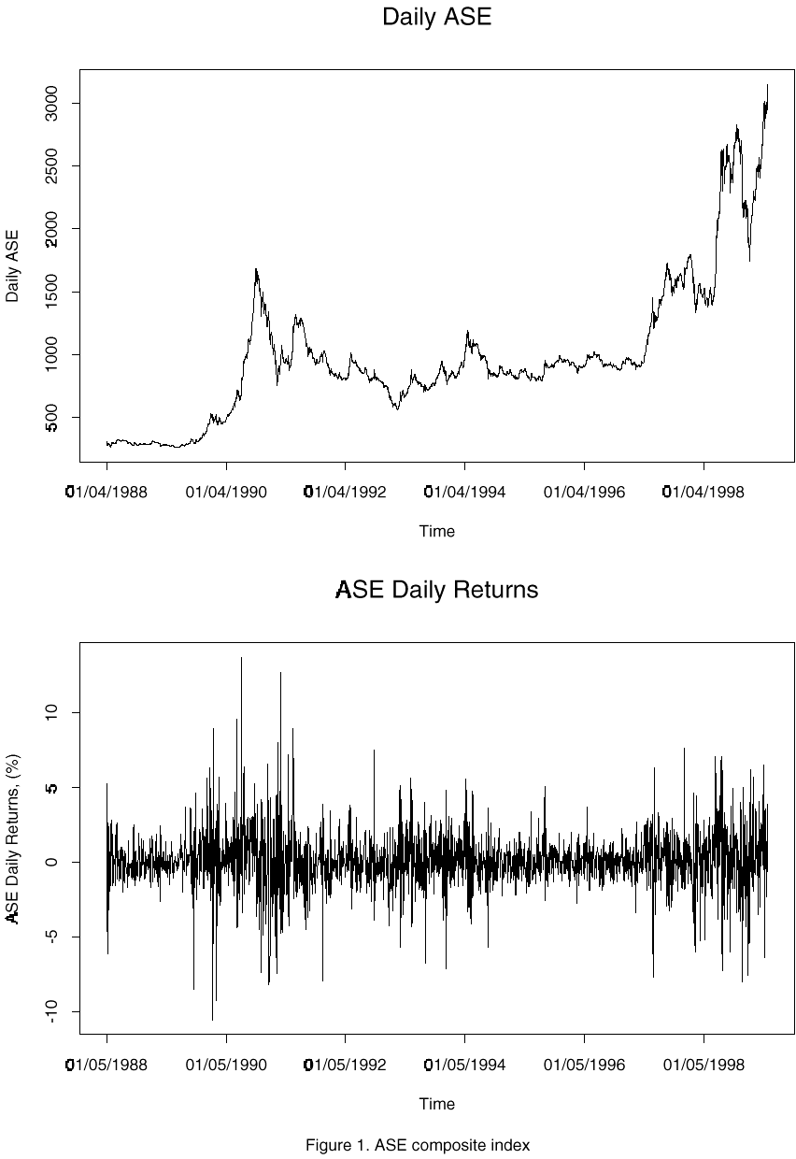
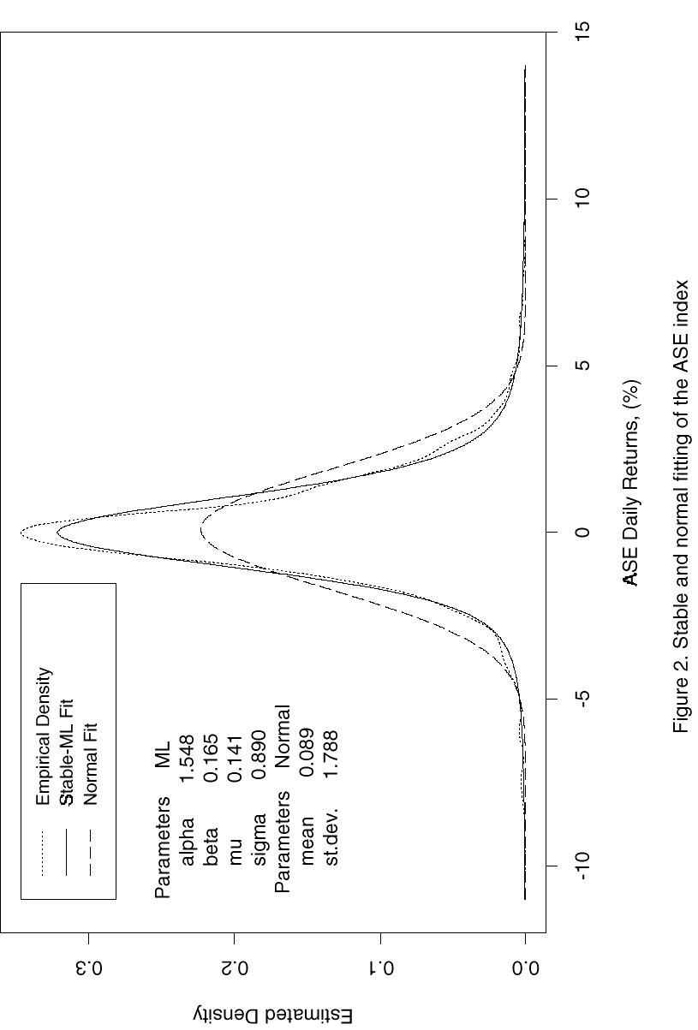
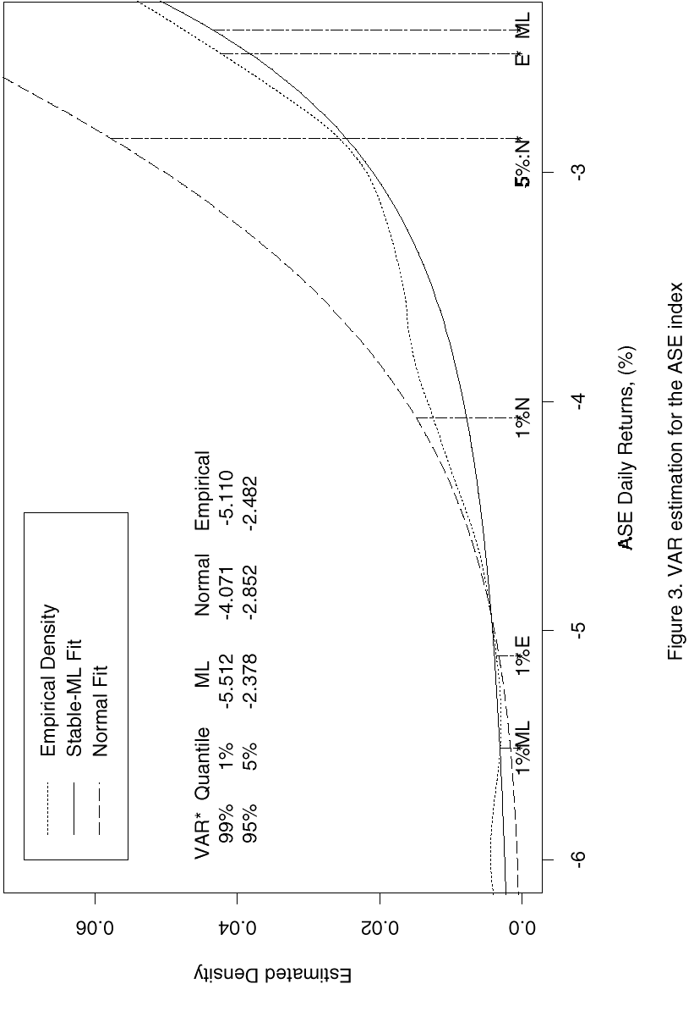

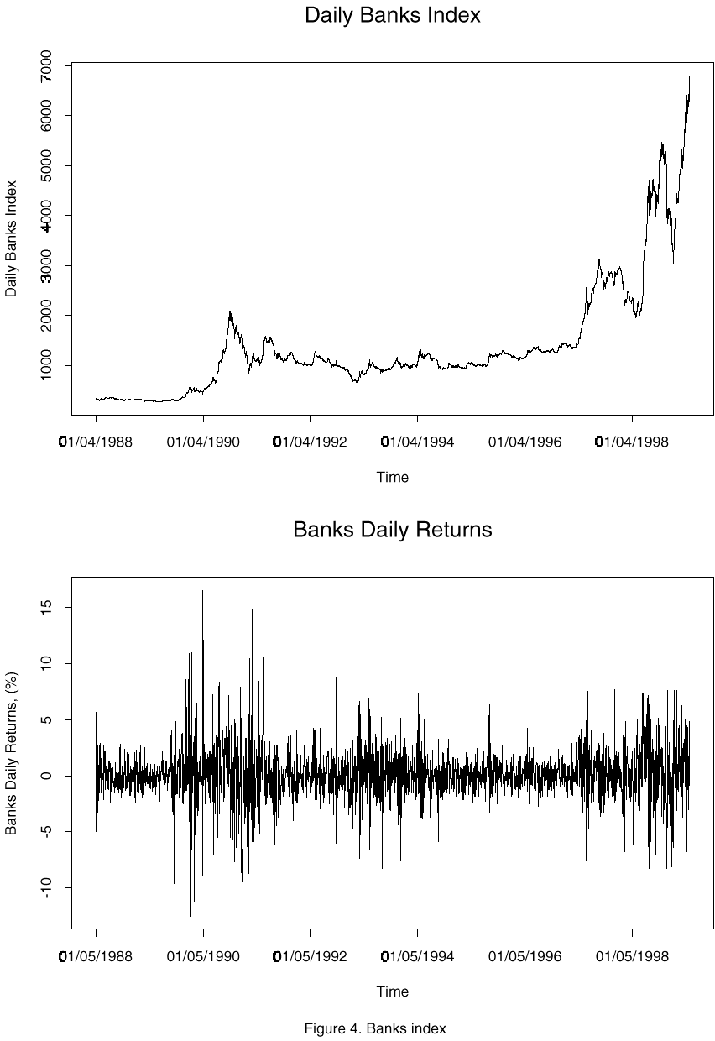
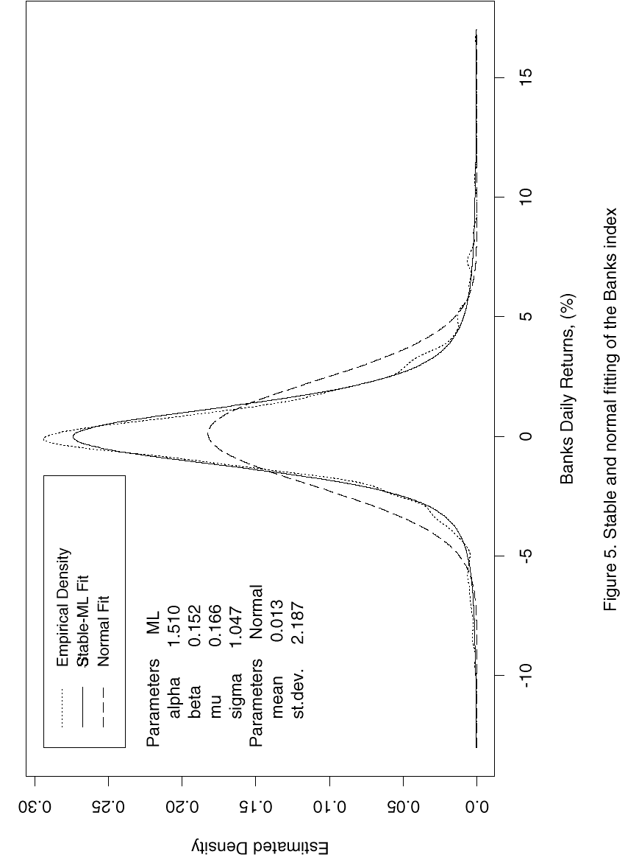
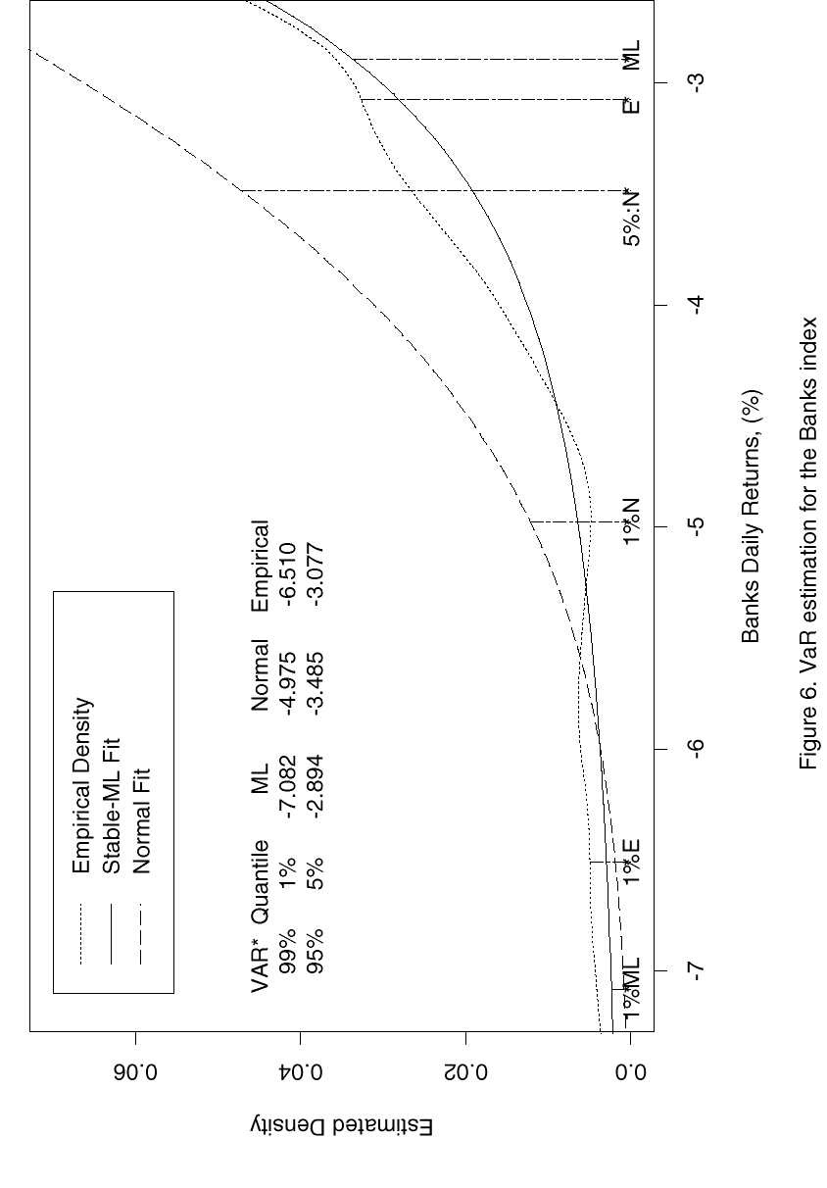
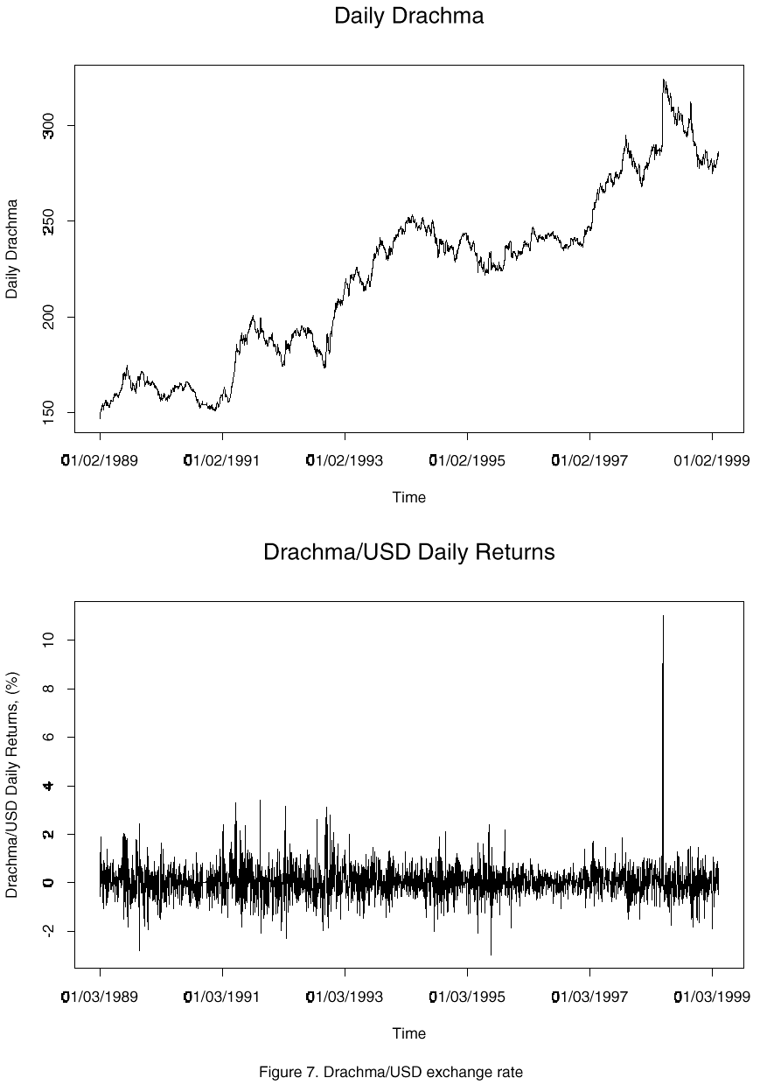
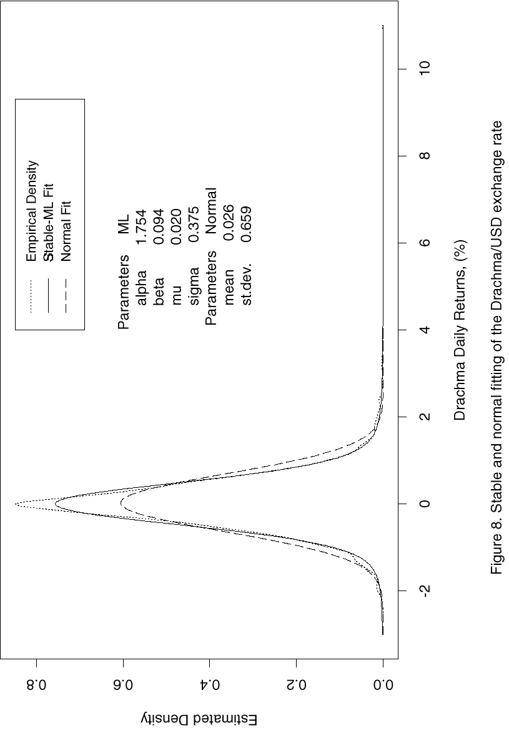
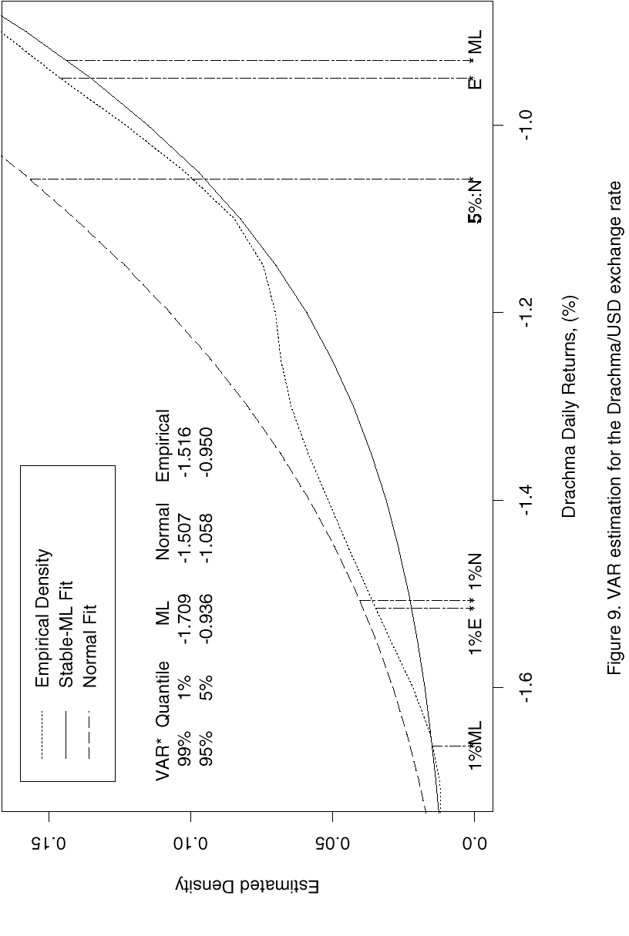

The research of S.T. Rachev was supported by the DFG grants.
Definition of Value at Risk is provided in Section 3.2.
For a survey of the Value-at-Risk models, see Jorion (1996); Khindanova and Rachev (1999).
If the risk factor does not enter linearly (as in a case of an option), then a linear approximation is used.
Scenarios include possible movements of the yield curve, changes in exchange rates, etc. together with estimates of the underlying probabilities.
A stable VaR model assumes that the portfolio return distribution follows a stable law, whereas a normal approach describes the portfolio returns using a normal distribution.
Khindanova, Rachev, and Schwartz (1999) reported that the stable modeling outperforms the normal modeling in both in-sample and forecasting VaR evaluations.

